

CA Clarity PPM v13.3   
CA Clarity PPM v14.1  
CA PPM v14.2

Strategic Alignment Documentation  
Release 4.1.2 – Installation Procedure

**Table of Contents**

1. Installation Instructions 3

1.1. Pre-reqs 3

1.2. Installing the Application 3

1.3. Post-installation procedures 5

1.4. Installing Demo Data 7

1.5. Demo Data Post-Installation 7

2. Known Issues 11

3. Technical Summary 11

3.1. Object Description 11

3.2. Pages 12

3.3. Processes 13

# Installation Instructions

## Pre-reqs

Strategic Alignment assumes:

1. You have **XOG** installed for the proper version (v13.3, v14.1, v14.2)
2. Increase XOG memory size to 1.5GB
   1. Go to your XOG Bin Folder (i.e. c:\apps\clients\xog\bin)
   2. Edit XOG.BAT in Notepad++
   3. Search for the string “**-Xmx**” using <CTRL+F>
   4. Replace the number that follows –Xmx with 1536m – like this: **-Xmx1536m**
   5. Save and Close Notepad++
3. You have a **user** called “**xog**” that has a password “**gox**” with **all access rights** to xog stuff in.
4. **If you want to use the Strategic Heat Maps, Hierarchies, Word Trees and Sankey Diagrams you will need to load the “Hierarchical Views” package as a pre-requisite** to this installation. If you don’t want it – expect errors on the installation for file “60-SeedData_customObjectInstance_2.xml”. If you later decide to load the Hierarchical Views, Please notice you should re-process this file AFTER loading Hierarchical Views.

## Installing the Application

1. Login as Administrator
2. Navigate to System Options
3. Set your Login Timeout to a large number (300) to make sure XOG doesn’t timeout during the installation
4. Download the Strategic Alignment ZIP file from the CA Wiki page.
5. Unzip the package file into your c:\temp folder.
6. Navigate to C:\Temp\StratAlignment_v4_1
7. Right-Click the file “StratAlignment_v4Install.bat” and select “Edit” from the Drop Down Menu
8. Locate the line where the XOG_HOME variable is set and replace the path to reflect your XOG installation path
9. Locate the line where the SERVERNAME variable is set and replace the value with your server name or IP address
10. Locate the line where the PORTNUMBER variable is set and replace it with the appropriate value (normally, it’s 80)
11. Locate the line where the USERNAME variable is set and replace it with the username you will use (default is the ‘xog’ user)
12. Locate the line where the PASSWORD variable is set and replace it with the password for that user (default is ‘gox’)
13. If you are loading into a new Dataset which might have changes in the Business Alignment page for Projects (or Alignment & Risk for Ideas) it may be a good idea to comment out the lines referring to the “Stock Views”. They may be identified with file names starting in “6E”.
    1. Replace “Call” with “rem Call” for those lines
14. Save this file
15. If there are any additional instructions inside the file – please follow those instructions
16. Run the file by double-clicking it.
17. Navigate to C:\Temp\StratAlignment_v4_1\output
18. Check all the output files for errors.
19. You shouldn’t see any errors. If you do, try to verify the reason and correct it. It’s ok to run it again after you correct something. If you don’t find the problem, drop me a note and I’ll try to help you out.
20. If you find an empty file it may be because XOG Timed Out before writing the log file. Normally, the file will have been executed correctly after a while. You may run only that file again, just to be sure, or you can check CA PPM and see if the changes were correctly applied.
21. Security warnings for Pages and Portlets are normal – they will be corrected when the Groups are loaded. Security warnings for Groups are also normal – they will be corrected when Seed Data is loaded.
22. If the **06C-StockObjectCustomAttributes_inv.xml** times out (output file empty, size = 0) open the investment objects (Project, Idea, Service, Application, etc) to verify the strat_corp_alignment, strat_bu_alignment, strat_dept_alignment and strat_fund_source are available.

## Post-installation procedures

1. Login to Clarity with “Admin”
2. Go to the Admin tool
3. Click on Processes
4. Filter all processes starting with “Strat”.
5. Activate all listed processes by clicking on them, navigating to “validation” and clicking on “Validate All and Activate”.
6. If you wish to use the new Dimensional Alignment attributes in Portfolios:
   1. Open the “Portfolio Investment” object
   2. Click “Attribute Registry”
   3. Add the Alignment attributes to the Registry. The Default dimensions are Business Unit, Department and Corporate. The attributes are Business Unit Alignment, Department Alignment and Corporate Alignment – respectively
   4. Add the Overall Alignment Score attribute as well
   5. Save and Return
7. There are known issues with Links and Actions. You will need to perform these steps:
   1. Open the “Strategic Indicator” object
   2. Click Linking
   3. Look for the “General SubPage Strategic Indicator Indicator Target List link” link:
      * Copy the Action ID in the “Action” column (it should look like **SubPage.5070099.actionLink**)
      * Click on the Link Name and Copy the Link ID (it should look like **strat_kpi.strat_kpi_target.5039212.link**)
   4. Look for the “General SubPage Strategic Indicator Indicator Measurement List link” link:
      * Copy the Action ID in the “Action” column (it should look like **SubPage.5070100.actionLink**)
      * Click on the Link Name and Copy the Link ID (it should look like **strat_kpi.strat_kpi_measure.5039212.link**)

|  |  |  |  |
| --- | --- | --- | --- |
| Ref | Link Name | Action ID | Link ID |
| A | General SubPage Strategic Indicator Indicator Target List link |  |  |
| B | General SubPage Strategic Indicator Indicator Measurement List link |  |  |

* 1. Open the “Strategic Item” object
  2. Click Linking
  3. Look for the “Strategic Item Top Down Planning by Stage Link” link:
     + Copy the Action ID in the “Action” column (it should look like **SubPage.5070110.actionLink**)
     + Click on the Link Name and Copy the Link ID (it should look like **strategic_item.strat_td_planning**)

|  |  |  |  |
| --- | --- | --- | --- |
| Ref | Link Name | Action ID | Link ID |
| C | Strategic Item Top Down Planning by Stage Link |  |  |

* 1. Open the 15-Queries_links.xml file in Notepad++ and run a “Replace Command” with the following data, then Save.

|  |  |
| --- | --- |
| From | To |
| SubPage.5093101.actionLink | <the Action ID for the “A” line on the Table above, such as **SubPage.5070099.actionLink**> |
| SubPage.5093102.actionLink | <the Action ID for the “B” line on the Table above, such as **SubPage.5070100.actionLink**> |
| SubPage.5093105.actionLink | <the Action ID for the “C” line on the Table above, such as **SubPage.5070110.actionLink**> |

* 1. Open the C:\Temp\StratAlignment_v4_1\15-Views_links.xml file in Notepad++ and do a “Search and Replace” using <CTRL+H> with the following data, then Save.

|  |  |
| --- | --- |
| From | To |
| strat_kpi.strat_kpi_target.5050193.link | <the Link ID for the “A” line on the Table above, such as **strat_kpi.strat_kpi_target.5039212.link** > |
| strat_kpi.strat_kpi_measure.5050193.link | <the Link ID for the “B” line on the Table above, such as **strat_kpi.strat_kpi_measure.5039212.link** > |

1. Navigate to C:\Temp\StratAlignment_v4_1
2. Right-Click the file “StratAlignment_v4Install_PostValidation.bat” and select “Edit” from the Drop Down Menu
3. Locate the line where the XOG_HOME variable is set and replace the path to reflect your XOG installation path
4. Locate the line where the SERVERNAME variable is set and replace the value with your server name or IP address
5. Locate the line where the PORTNUMBER variable is set and replace it with the appropriate value (normally, it’s 80)
6. Locate the line where the USERNAME variable is set and replace it with the username you will use (default is the ‘xog’ user)
7. Locate the line where the PASSWORD variable is set and replace it with the password for that user (default is ‘gox’)
8. Save this file
9. If there are any additional instructions inside the file – please follow those instructions
10. Run the file by double-clicking it.
11. Navigate to C:\Temp\StratAlignment_v4_1\output
12. Check all the output files for errors.
13. You shouldn’t see any errors. If you do, try to verify the reason and correct it. It’s ok to run it again after you correct something. If you don’t find the problem, drop me a note and I’ll try to help you out.
14. If you find an empty file it may be because XOG Timed Out before writing the log file. Normally, the file will have been executed correctly after a while. You may run only that file again, just to be sure, or you can check CA PPM and see if the changes were correctly applied.
15. Manually change the Idea and the Project Views to add the following:
    1. Add “Strategic Alignment” section to Alignment & Risk (on Ideas) and Business alignment (on Projects)
    2. Add Overall Strategic Score, Corporate Alignment, Business Unit Alignment and Department Alignment to the Left Column
    3. Add Strategic Funding Source and Supported Goals to the Right Column.
    4. On the View’s “Fields” add the Image Icons to the Alignment Attributes.
16. You need to go to the Administration Menu and configure two new Time-Slices:
    1. Request Name must be “Planned Cost for Top-Down Plan”; field Investment Cost Plan; monthly rollover; monthly period; 30 periods; Start Jan 1st 2015
    2. Request Name must be “Planned Benefit for Top-Down Plan”; field Investment Benefit Plan; monthly rollover; monthly period; 30 periods; Start Jan 1st 2015
17. If you are not using the Hierarchical Views (Strategic Heat Map and Hierarchy portlets), perform these additional steps:
    1. Go to Portlet Pages
    2. Find “Strategic Item Default Layout”
    3. Click “Tabs”
    4. On the “Strategic Map” tab de-select the “Active” column
    5. Repeat the same process for the “Hierarchy” tab of the “Strategic Indicator Default Layout” Portlet Page

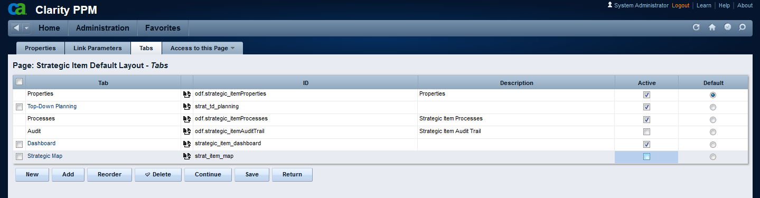

* 1. Remove The Hierarchy Icon from:
     + Object Strategic Item, List View
     + Object Strategic Indicator, List View
     + Portlet: Strategic Hierarchy with Indicators
     + Portlet: Strategic Indicator Hierarchy

## Installing Demo Data

1. After installing the application, if demo data is necessary, follow these steps
2. Right-Click the file “StratAlignment_v4Install_Demo.bat” and select “Edit” from the Drop Down Menu
3. Locate the line where the XOG_HOME variable is set and replace the path to reflect your XOG installation path
4. Locate the line where the SERVERNAME variable is set and replace the value with your server name or IP address
5. Locate the line where the PORTNUMBER variable is set and replace it with the appropriate value (normally, it’s 80)
6. Locate the line where the USERNAME variable is set and replace it with the username you will use (default is the ‘xog’ user)
7. Locate the line where the PASSWORD variable is set and replace it with the password for that user (default is ‘gox’)
8. Save this file
9. Run “StratAlignment_v4Install_Demo.bat”

## Demo Data Post-Installation

To finish installing demo-data, follow these steps:

1. As an Admin, login to the application. Navigate to “Evaluation Cycles” under “Strategic Alignment”

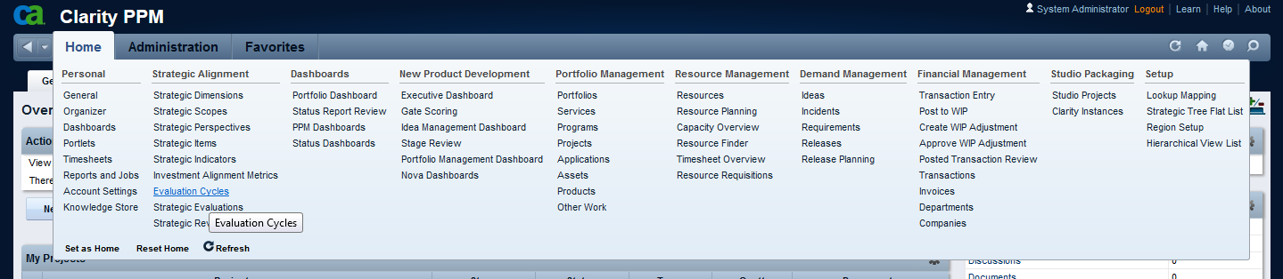

1. You’ll see three different cycles. They are all in Wait state.   
   Change the Cycle action to “Start” and Save, better to do it one at a time, not all three together.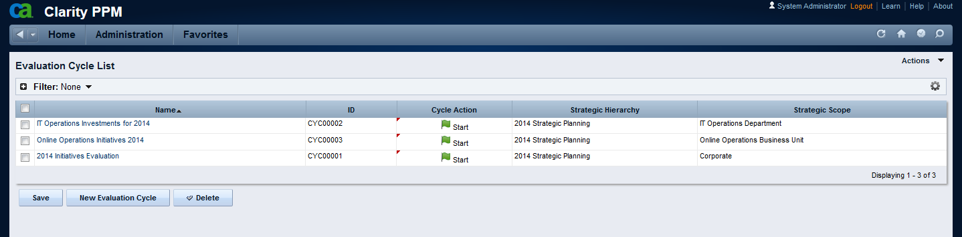
2. Now there should be a process on each one of those Cycles, and they should be at the “Distribute Evaluation” Step. If the process is in error for any reason, just restart the process – or cancel and start another instance. This is known to happen for an unknown reason.

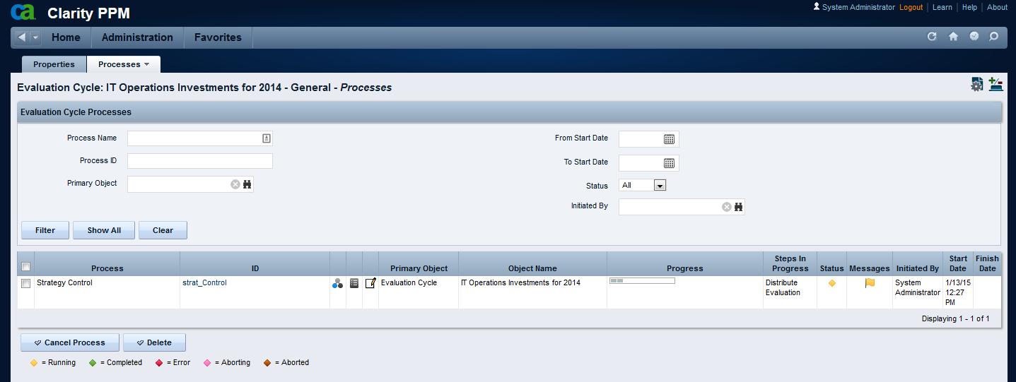

1. Change the Cycle Action to “Close” for all three Cycles and Save. If you need to restart the processes, you can just select the corresponding cycles on the List View and use the new Action “Manually Start Process” from the Actions Menu.

It is better to do it one at a time, not all three together.

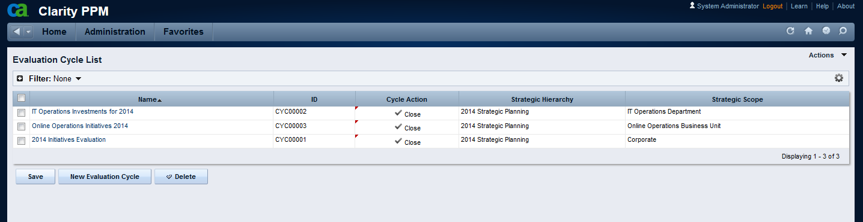

1. All three processes should now finish successfully.

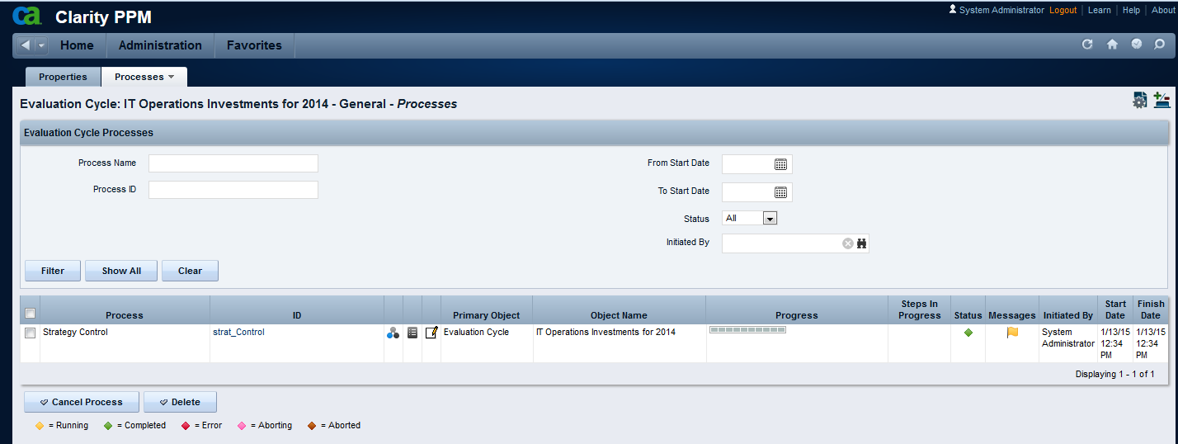

1. The installation process of Demo Data is now complete.

# Known Issues

If you get an error “501 – Not Implemented” when navigating to Dashboards or Hierarchical views, clear your **browser** **and** **server** caches and try again.

If that doesn’t solve the issue you may have missed a step on the installation and we may be required to fix a few links/actions manually. Send me an [email](mailto:alexandre.assis@ca.com) and I’ll get back to you as soon as possible.

# Technical Summary

## Object Description

|  |  |  |  |  |
| --- | --- | --- | --- | --- |
| **Object** | **ID** | **Master – Subobject** | **Description** | **Additional information** |
| Strategic Dimension | strat_dim | Master Object | Dimensions are types of Strategic Maps and are related to Alignment Attributes in the Investment Object.  e.g. The “Department” dimension will be used to calculate the “Department Alignment Score” | Three Dimensions are delivered as “Seed Data”:   * Department; * Business Unit; * Corporate   Additional dimensions can be easily created |
| Strategic Scope | strat_scope | Master Object | Scopes are instances of dimensions.  e.g. The “IT Operations Department” is a scope that allows the IT Strategy Team to build an IT Strategy, either stand-alone or linked to a Corporate Strategy Plan. | Five Scopes are delivered as “Seed Data”. |
| BSC Perspective | strat_bsc_persp | Master Object | BSC Perspectives are aligned to the Balanced Scorecard tool.  e.g. the “Customer” perspective. | Four Perspectives are delivered as “Seed Data”:   * Financial; * Customer; * Internal Processes; * Learning and Growth |
| Strategic KPI | strat_kpi | Master Object | KPIs are used to set targets and capture measurements on Key Indicators related to your Strategic Plan. KPIs are scope-specific.  e.g. “Customer Satisfaction Index” is a Key Indicator of the “Corporate Strategy” scope; “IT Customer Index” is a Key Indicator of the “IT Operations” scope  KPIs can also have their own hierarchy and cascade status from child KPIs to parent KPIs | KPIs are delivered as “Demo Data” |
| KPI Target | strat_kpi_target | Subobject to Strategic KPI | Targets are used to establish your goals for a specific period.  e.g. We set a Target of “95” for “Customer Satisfaction Index” KPI at the end of 2011, “97” at the end of 2012, “99” at the end of “2013” | Targets are delivered as “Demo Data”. Demo targets are set by Year. |
| KPI Measurement | strat_kpi_measure | Subobject to Strategic KPI | Measurements are used to assess how we’re comparing to our targets  e.g. We have measured “Customer Satisfaction Index” on Q1 2011 as “90” and Q2 2011 as “92” | Measurements are delivered as “Demo Data”. Demo measures are set by Year, Quarter or Month, depending on the nature of the KPI. |
| Item Status Scale | strat_item_scale | Subobject to Strategic KPI | The Item Scale is used to normalize different KPI scales to allow more flexibility. By default the scale is initialized with a given range for each value, but those ranges can be personalized by KPI.  e.g. From 95% to 103% = On Target; From 103% to 9999% = Exceeded Target | Item Scales are delivered as “Demo Data”. |
| Strategic Item | strategic_item | Master Object | Strategic Items are the “heart” of the system. Items are created and can be related to each other in a parent-child relation building a “Strategic Hierarchy”. Some facts about Strategic Items:   * Items are related to a Scope; * Items may be related to a Perspective; * Items are classified in Levels; * Items may have a Parent Item; * Items may be related to KPIs (that monitor their execution) * Items may be related to Alignment Metrics (that help evaluate Investments against those items) |  |
| Investment Alignment Metric | strat_align_metric | Master Object | Alignment Metrics are used to assess Investments (Ideas, Projects, Programs, etc) against the Strategic Items in your Strategic Plan.  e.g. “$ Cost Reduction” | Alignment Metrics are delivered as “Demo Data”. |
| Alignment Scale | strat_metric_scale | Subobject to Investment Alignment Metric | The Metric Scale is used to normalize different Metrics in a way they can all be compared and used in a formula.  e.g. $ Cost Reduction of 500,000 is “Above Average”, giving an alignment score of “60” | Alignment scales are part of the Alignment Metrics “Demo Data”. |
| Evaluation Cycles | strat_eval_cycle | Master Object | Evaluation Cycles are used to Evaluate initiatives against your Objectives by using the Alignment Metrics associated with those Objectives. | Three evaluation cycles, one for each Dimension, are delivered as “Demo Data”. |
| Strategic Evaluations | strat_evaluation | Master Object | Strategic Evaluations are created automatically by Workflow during the execution of a cycle. They contain a “Question” about an “Investment” that should be answered by the Investment’s Manager according to the Investment Business Case. They are subject to instance-based security – only the Investment Manager can Edit these records (as well as the Administrator) | Strategic Evaluations for the three Evaluation Cycles are delivered as “Demo Data” |
| Strategic Tree Flat | strat_tree_flat | Master Object | This object is generated automatically via Workflow and is just used as an auxiliary table for building Multi-Scope Portlets. Users should NOT have access to this object in the UI. | Strategic Tree Flat items are delivered as part of “Demo Data” referring to Strategic Items and the three Scopes. |

## Pages

|  |  |  |  |
| --- | --- | --- | --- |
| **Page** | **ID** | **Custom TABs** | **Description** |
| [BSC Perspective Default Layout](http://claritylatam50/niku/nu#action:npt.getPage&pageId=odf.strat_bsc_perspFrame&id=5009062&obsType=Page&principal_type=SYSTEM&principal_id=0) | odf.strat_bsc_perspFrame | Dashboard | Portlets showing Strategic Items Hierarchy and Projects Hierarchy related to that BSC Perspective |
| [Evaluation Cycle Default Layout](http://claritylatam50/niku/nu#action:npt.getPage&pageId=odf.strat_eval_cycleFrame&id=5009056&obsType=Page&principal_type=SYSTEM&principal_id=0) | odf.strat_eval_cycleFrame | n/a |  |
| [Investment Alignment Metric Default Layout](http://claritylatam50/niku/nu#action:npt.getPage&pageId=odf.strat_align_metricFrame&id=5009038&obsType=Page&principal_type=SYSTEM&principal_id=0) | odf.strat_align_metricFrame | n/a |  |
| [Strategic Dimension Default Layout](http://claritylatam50/niku/nu#action:npt.getPage&pageId=odf.strat_dimFrame&id=5009044&obsType=Page&principal_type=SYSTEM&principal_id=0) | odf.strat_dimFrame | n/a |  |
| [Strategic Evaluation Default Layout](http://claritylatam50/niku/nu#action:npt.getPage&pageId=odf.strat_evaluationFrame&id=5009050&obsType=Page&principal_type=SYSTEM&principal_id=0) | odf.strat_evaluationFrame | n/a |  |
| [Strategic Item Default Layout](http://claritylatam50/niku/nu#action:npt.getPage&pageId=odf.strategic_itemFrame&id=5009020&obsType=Page&principal_type=SYSTEM&principal_id=0) | odf.strategic_itemFrame | Top-Down Planning  Dashboard  Strategic Map | Properties page pertaining to Top-Down Planning  Strategic Items Hierarchy and Projects Hierarchy  Graphical Hierarchical Views |
| [Strategic KPI Default Layout](http://claritylatam50/niku/nu#action:npt.getPage&pageId=odf.strat_kpiFrame&id=5009026&obsType=Page&principal_type=SYSTEM&principal_id=0) | odf.strat_kpiFrame | Dashboard  KPI Hierarchy | Strategic Items Hierarchy and Projects Hierarchy  Graphical Hierarchical Views |
| [Strategic Review](http://claritylatam50/niku/nu#action:npt.getPage&pageId=strat_ReviewFRAME&id=5009067&obsType=Page&principal_type=SYSTEM&principal_id=0) | strat_ReviewFRAME | Strategic Review  Top-Down Planning  Strategic Projects  Strategic KPIs  Evaluation Cycle Results | Hierarchy of Strategic Items with their KPIs  Hierarchy of Strategic Items with their Top-Down info  Hierarchy of Strategic Items with their supporting Projects  KPI Targets and KPI Measurements information  Investment Alignment calculation from Evaluation Cycles |
| [Strategic Scope Default Layout](http://claritylatam50/niku/nu#action:npt.getPage&pageId=odf.strat_scopeFrame&id=5009032&obsType=Page&principal_type=SYSTEM&principal_id=0) | odf.strat_scopeFrame | n/a |  |
| [Strategic Tree Flat Default Layout](http://claritylatam50/niku/nu#action:npt.getPage&pageId=odf.strat_tree_flatFrame&id=5009014&obsType=Page&principal_type=SYSTEM&principal_id=0) | odf.strat_tree_flatFrame | n/a |  |

## Processes

|  |  |
| --- | --- |
| **Process** | **Description** |
| Strategic Alignment Metric Initialize | Every time you create a new Investment Alignment Metric this process creates a blank set of “Alignment Scales” From Null (0) to Extraordinary (100) |
| Strategic Allocation Percentage | This process is used to Initialize the Allocation Percentage used in Top-Down Planning with the same value as the Weight % calculated for each Item. On Multi-Scope systems, the overlapping nodes (i.e. a “parent” with “children” in various scopes) will do an equal split between the different scopes, as Weights sum 100% *per scope*  Also, Initializes “Allocations” and “Top-Down Received” attributes with Zero value for Benefits, Funds & FTEs. |
| Strategic Fund Allocation Initialization | Copy Top-Down Planning values to Allocated values for Lower Level Items  Resets Allocated Values for Parent Items to zero. |
| Strategic Item – Build Tree Flat | Every time you change a Strategic Item this process will create records in the Strategic Tree Flat table with the Item’s parents and children in all levels up and down. |
| Strategic Item – Clean up Tree | Every time you delete Strategic Items you should manually execute this process to Clean Up the Strategic Tree Flat table |
| Strategic Item – Rebuild Tree | Use this to rebuild the Strategic Tree Flat table in case of need (Example: if you XOG in new Strategic Items while the “Build” Process is inactive). |
| Strategic Item Status Initialize | Every time you create a new KPI this process creates a default set of “Item Scales” From 0 (Undefined) to 6 (Exceeded Target) and you may adjust the Percentage ranges corresponding to each one. |
| Strategic KPI Calculation | Every time you change KPI Targets, KPI Measurements, KPI Settings or Status Settings, Item Settings, or the KPI Item Status Scale you should run this process manually to update their “KPI Target x Measurement”, “KPI Rollup from Children”, “KPI Status” and “Item Status” attributes and the Strategic Item’s corresponding attributes. The process is available as an Action both from the Strategic Item and the Strategic KPI Properties and List views. |
| Strategic Portfolio Creation | You should execute this process after finishing your Top-Down Planning cycle to generate the corresponding portfolios automatically. You don’t need to do it for all levels, just for those you want to manage using the Portfolio Plans, Targets and Waterlines. Lower Level Items get automatically included in parent items; Investments are selected based on the “Strategic Funding Source” attribute. |
| Strategic Rollup Allocated and Committed Funding | This process is used to sum the Allocated values and the Committed values all the way from the lower-level items to their parents. |
| Strategic Top-Down Planning Calculation | This process will distribute funds from the associated Strategic Item -> Downwards using the % Allocation defined.The values will go both to the Top-Down *Received* attributes and to the Top-Down attributes. The first ones hold this value in a read-only attribute. The second ones can be adjusted to allow for some “strategic reserve” of funds/FTEs. |
| Strategy Control | Every time you create a Strategic Cycle this process will help Distribute the Evaluation Questions; once they are answered it will Calculate Weights, Calculate the Alignment Scores and Update Investments. |